# Installation guide

## Installing libraries

The first step is ensuring that all necessary code libraries are installed:

* cdsapi
* xarray
* huracan (DNV) that should include all other necessary module
  + numpy
  + pandas
  + dask
  + math
  + os

If any of those is missing, just open a terminal window in Anaconda and type:

conda install *[name of the package]*

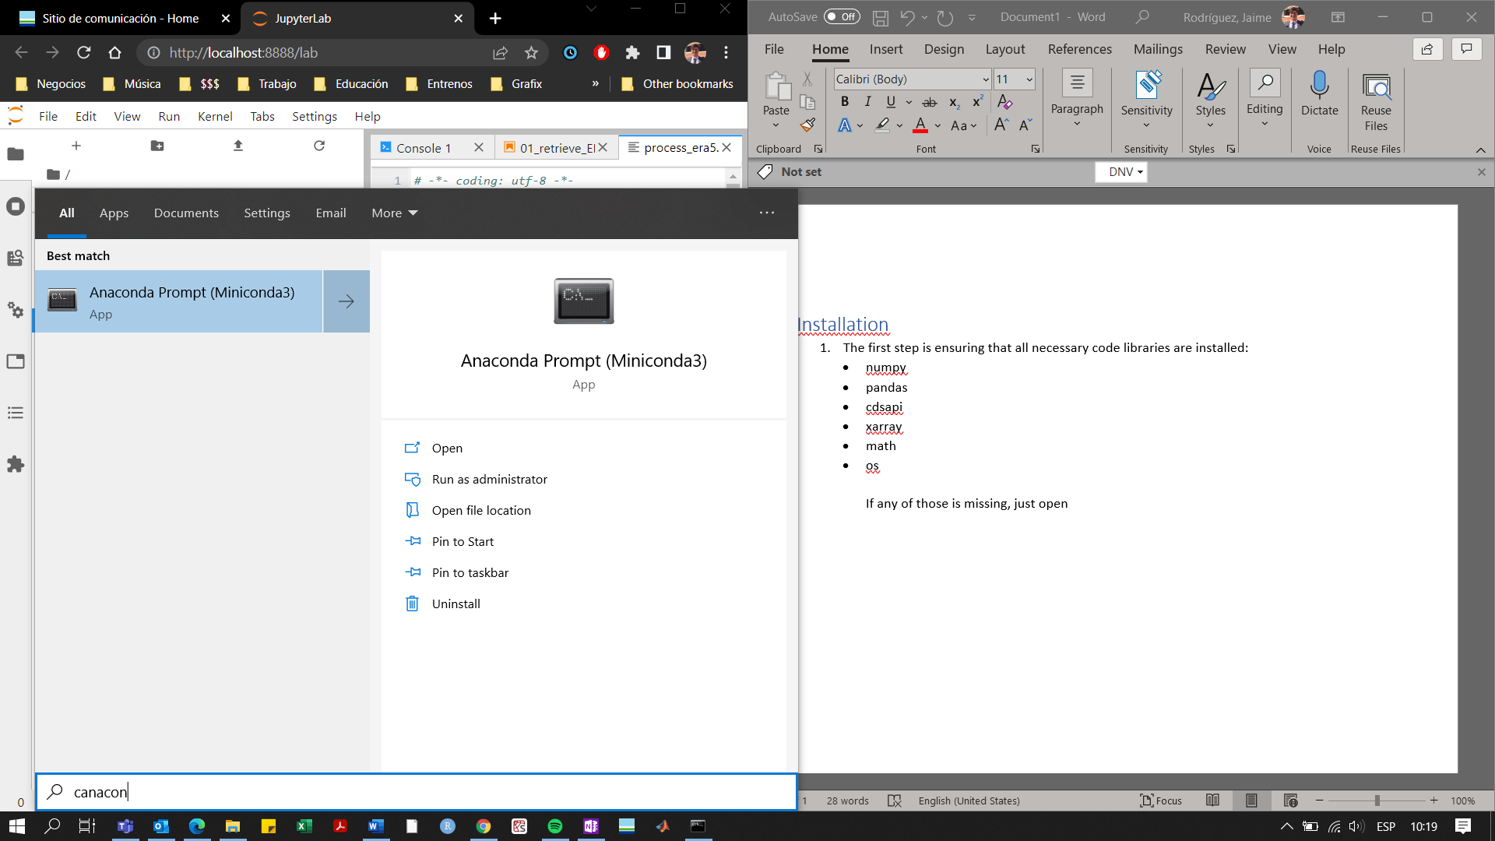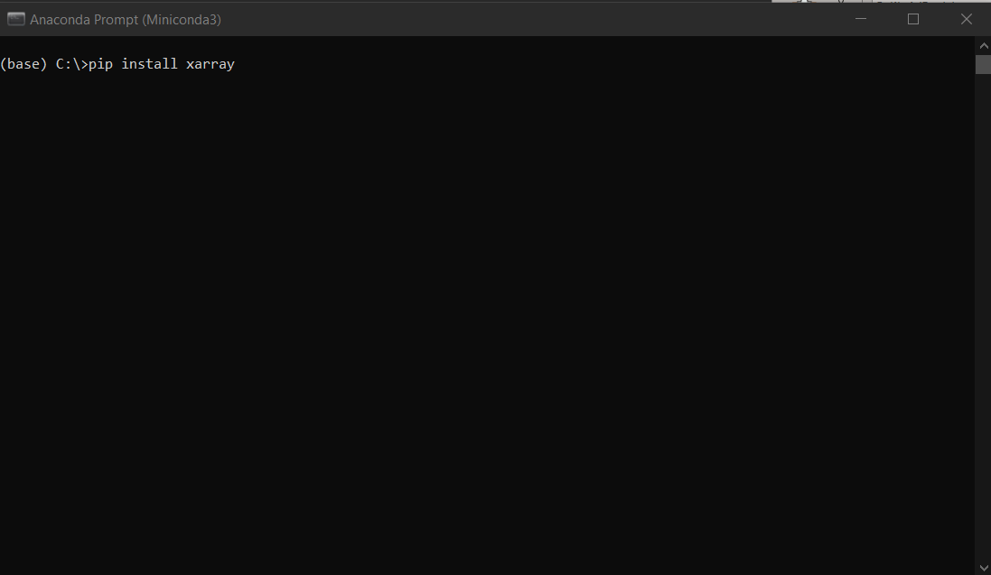

## Setting up the CDS API

The CDS API is the interface that will allow the code to access, query and send requests to the CDS database. The official guide may be found in the following [link](https://cds.climate.copernicus.eu/api-how-to), but here is a short breakdown and some helpful tips:

* 1. Creating an [account](https://cds.climate.copernicus.eu/user/register?destination=%2F%23!%2Fhome) in CDS
  2. Installing the CDS API Key
     1. Make sure you are logged in CDS
     2. Open the link above to the official guide, and under the ‘Install the CDS API Key’ section, there will be a terminal-like box with the following text:

url: https://cds.climate.copernicus.eu/api/v2

key: {uid}:{api-key}

where uid is your user id and api-key is your own user key. If you do not see your specific credentials, try logging in CDS again.

* + 1. Copy the aforementioned text into a blank .txt file.
    2. Click on Save As…, delete the default name, and change the file name to “.cdsapirc”, as shown in the picture below. Then make sure that this file is saved to the user HOME directory. Depending on your configuration, this could be one of the following:

C:\Users*[VERIT User name]*

or

C:\Users*\[VERIT User name]*\Documents

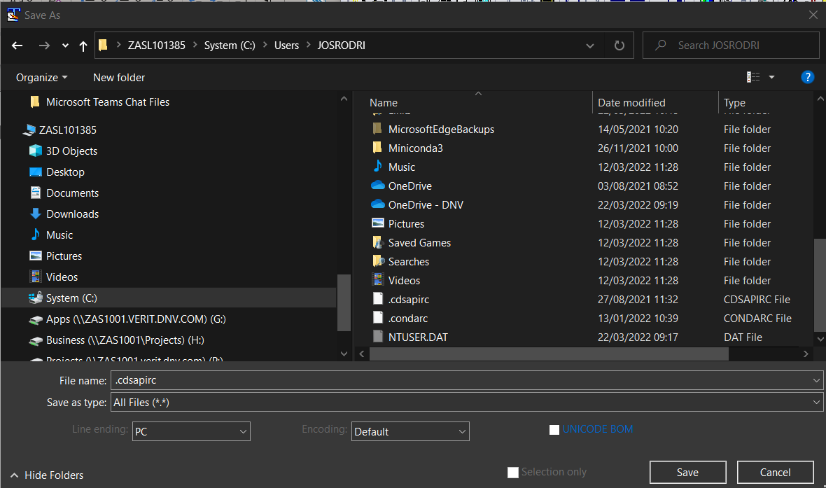

* 1. Installing the CDS API client (this requirement should be already completed after installing the libraries in the first step of this installation guide)

# User guide

The purpose of this tool is to query Copernicus CDS API ERA5 data and return the 9 nearest points data in .txt format. The tool file contains detailed use instructions in the different text boxes along the file, but this document will cover the most basic ones.

Important note

This notebook is mainly intended for the download of ERA5 reanalysys data from recent months or years that is not available from Wind Farmer: Analyst or Green Power Monitor (GPM) servers. Since data requests take some time to be fulfilled by CDS due to the high volume of requests it manages on a regular basis, downloading many years’ worth of data or a lot of variables may take a large amount of time. Should that be the case, running multiple instances of this notebook will allow to log several requests in the CDS queue simultaneously, which will significantly reduce the time needed to complete the download.

1. Once the tool package is downloaded and unzipped it, Huracan may be launched by clicking on the included .bat file.

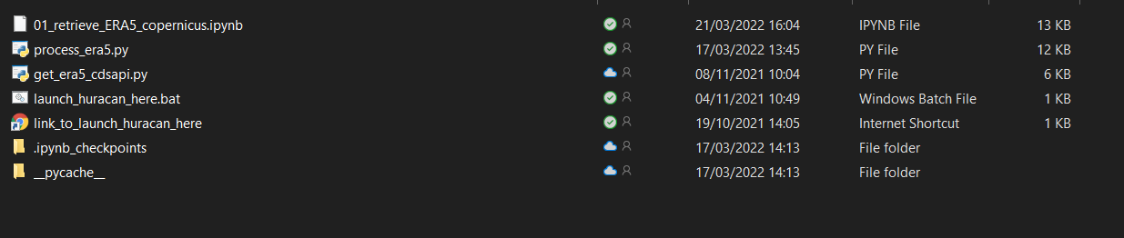

1. This will open a window in your internet browser. Click on the jupyter notebook file to open the tool. 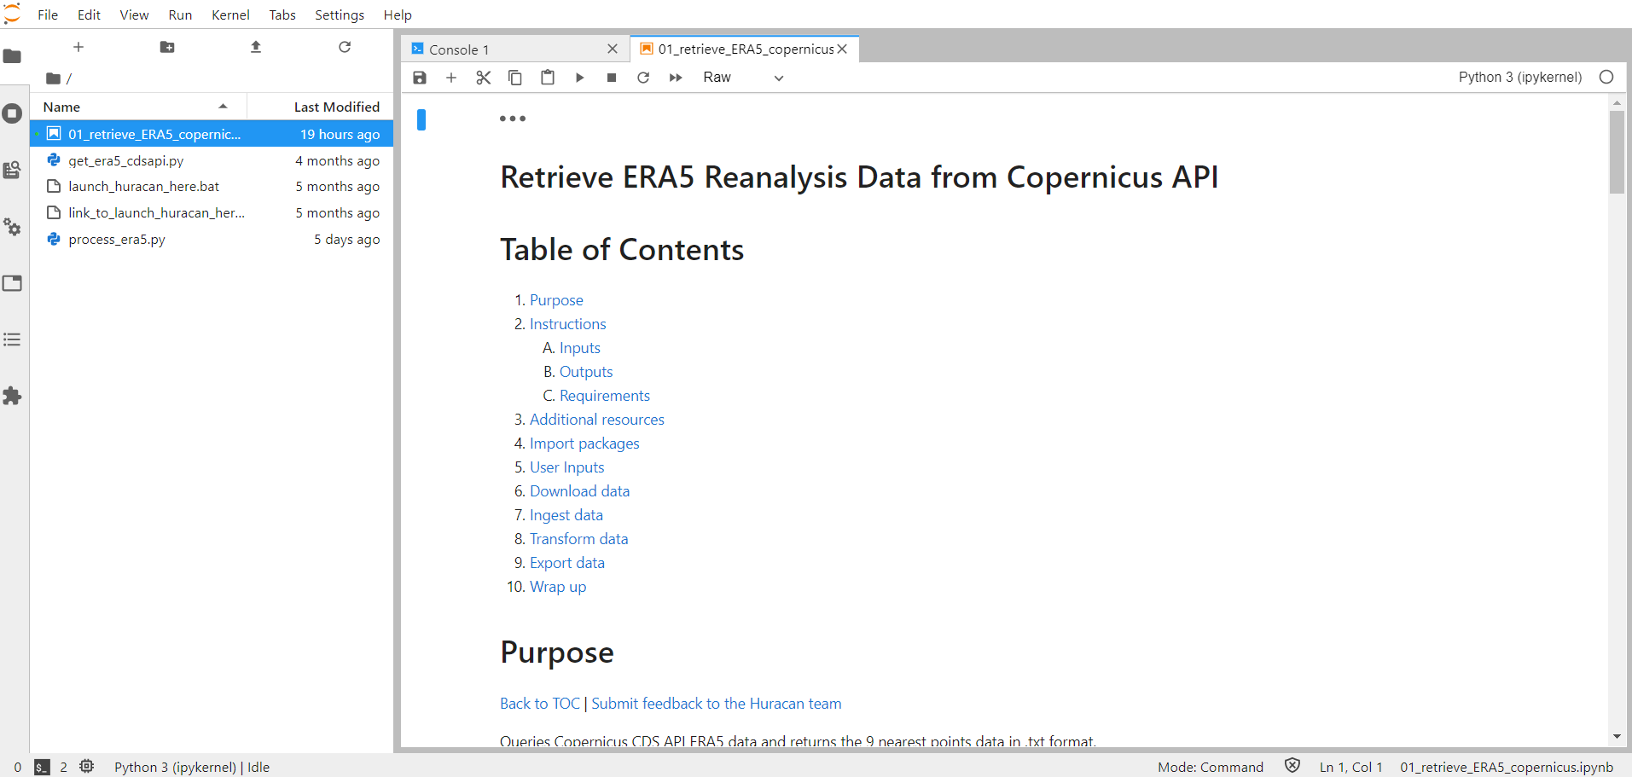
2. Go to the ‘User Inputs’ cell and fill in according to the user needs and input criteria:

* site: Name of the site (used for naming files generated in Outputs)
* lat: Latitude of the site (decimal deg.)
* lon: Longitude of the site (decimal deg.)
* outputDir: Output directory where .txt should be saved
* start_date: The start date for data query ('dd-mm-yyyy')
* end_date: The end date for data query ('dd-mm-yyyy')
* TandPData: Chose True or False (no quotation marks) to request separate temperature and pressure data files
* otherData: This tool is able not only to download wind data, but also other types of data like solar radiation, rain and hundreds of other variables. This field may be used to download those other variables. Variable names may be found in the data documentation [here](https://confluence.ecmwf.int/display/CKB/ERA5%3A+data+documentation).

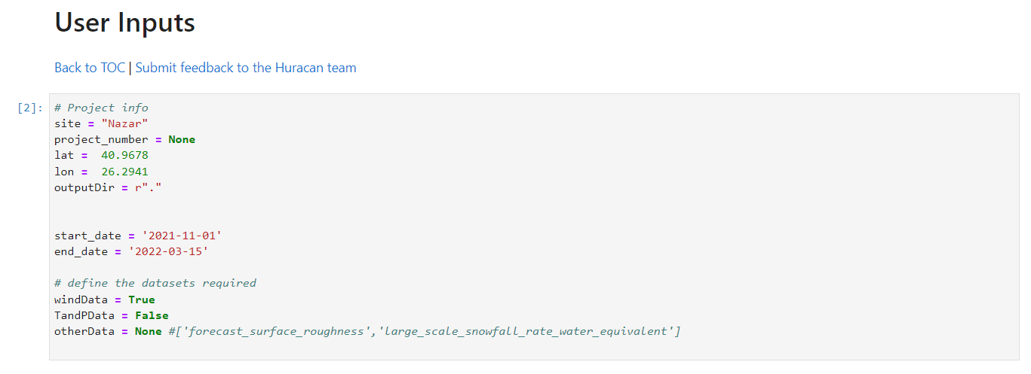

1. Once the inputs are completed, click on the ‘Restart the kernel, then re-run the whole notebook’ button in the jupyter taskbar: 
2. Once the requested data is downloaded, processed and ready to use, it will be saved in .txt format in the same directory where the tool is stored, unless a different output directory has been specified in the ‘User Inputs’ cell.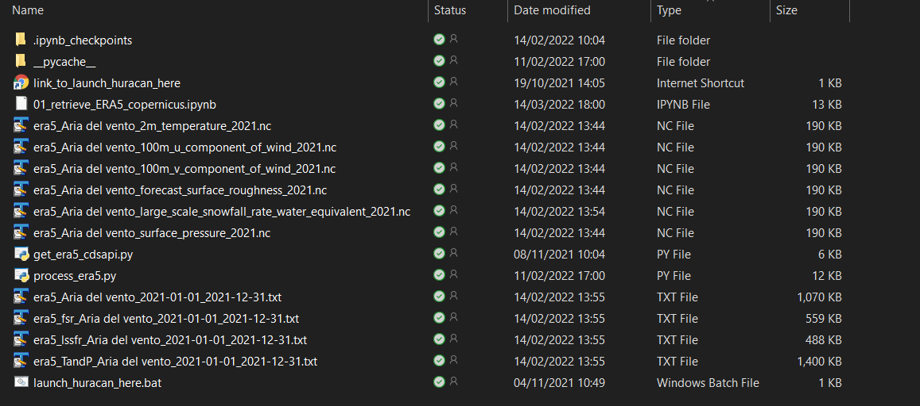

The following outputs will be present:

* Wind speed and direction data
* Temperature and pressure data, if enabled
* Any additional datasets requested, if enabled

As shown below, each output file contains specific variables recorded hourly at 9 coordinates paralleling 9 ERA5 cells. The central cell will be the closest one to the input coordinates, and the remaining 8 cells will be the 8 cells surrounding the central cell in the 8 cardinal directions (north, northeast, east, southeast, south, southwest, west and northwest). The file header contains the coordinates of each of those cells.

